**Protect patient information**

Microsoft Cloud for Healthcare helps support your customers for privacy, security, compliance, and interoperability of health data. It focuses on protecting patient information through the following ways:

Security - Protect against the latest threats with intelligent tools to help prevent attacks and react quickly to security events. For more information, see Security in Microsoft Cloud for Healthcare.

Compliance - Stay up to date with the latest requirements with the most comprehensive set of cloud compliance offerings. For more information, see Compliance in Microsoft Cloud for Healthcare.

Privacy - Maintain control of your data with confidence knowing that your data won't be used for commercial purposes. Also, any Personal Identifiable Information (PII) submitted by patients are handled according to any Data and Health Records regulations prevalent in patients’ region.

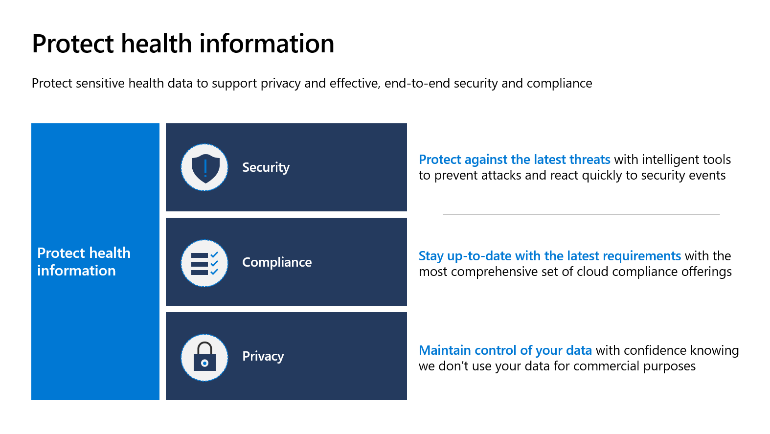

Next unit: Conceptual architecture